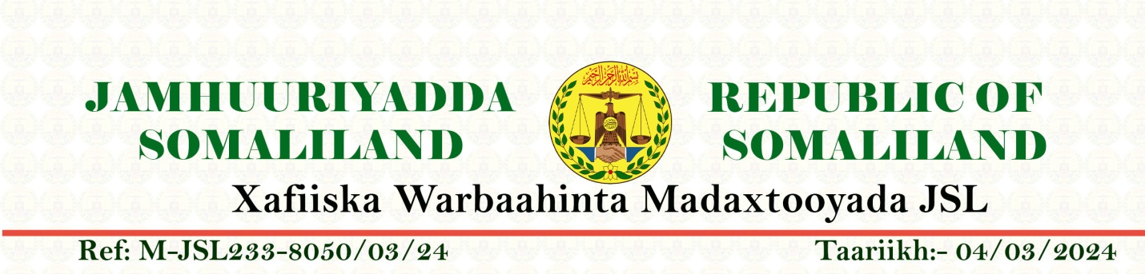
Spokesman of the President

Ref….X/A/M/JSL….002 Date: 19.12.2024

Subject: Profound Gratitude for Your Leadership on the Bill to Recognize Somaliland
Dear Honorable Mr. Scott Perry (Congressman);

On behalf of the Republic of Somaliland and its proud citizens, I wish to express our deepest and most heartfelt gratitude for your visionary leadership in introducing and advancing the Bill to recognize Somaliland’s sovereignty. This historic step reflects not only your steadfast commitment to justice and democracy but also your profound understanding of the aspirations of the Somaliland people, who have worked tirelessly to build a peaceful, democratic, and self-reliant nation in the Horn of Africa.

Mr. Scott, your efforts serve as a beacon of hope for Somaliland’s more than 33-years pursuit of international recognition, an acknowledgment of the stability, good governance, democracy and respect for human rights that our nation has consistently upheld.
At a time when much of the region faces turmoil and uncertainty, Somaliland has remained an anchor of peace, democracy and progress—a testament to the enduring spirit of our resilient people and their desire to contribute meaningfully to the global community.

The introduction of this Bill also underscores the deep and enduring partnership between Somaliland and the United States of America. It reflects America’s unwavering support for democratic principles and the rights of self-determining nations. Your courage and foresight in championing Somaliland’s case will forever remain in our collective memory, as it marks a pivotal moment in our journey toward recognition and greater engagement with the international community.

We are profoundly moved by your solidarity and commitment, and we pledge to continue our efforts to uphold the ideals and values that inspired this significant legislation.

Somaliland looks forward to working even more closely with the United States in the months and years to come, building on this remarkable foundation of friendship and shared purpose.

Once again, thank you for your extraordinary leadership, vision, and dedication. History will remember this as a turning point in Somaliland’s success story, made possible by the unwavering support of champions like you.

With the highest regard and gratitude,

Hussein Adan Igeh (Deyr)
The Spokesman of The President of the Republic of Somaliland

